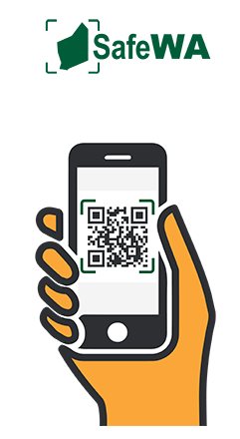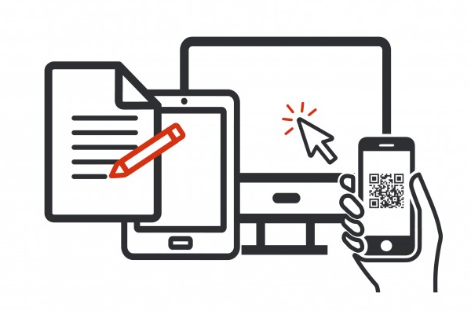
Contact tracing to commence Saturday
5th December SafeWA App.

From Saturday 5th December we will commence contact tracing within the Cockburn CRC Facility.
As such, all members and guests are requested to download the app, SafeWA prior to arriving at our Facility. We also ask that you please advise any groups and individuals planning on attending the Facility to also download the app prior to arriving.
SafeWA can be downloaded from the Apple App Store or Google Play.
The Department of Health’s SafeWA App ensures businesses and venues have a unique QR code for patrons to scan and register their attendance.
To avoid delays we strongly encourage you to download the app before you arrive and for express entry scan the QR code on your way into the Facility so you can show your electronic receipt as you enter.
Please follow the directions and signage at each entrance point to the Cockburn CRC Facility, staff will be available to assist if required.
As this is a new process, we ask you and your group/individual bookings allow extra time for the contact tracing check as you enter the club.
Please be patient with staff as they navigate through the changes.
For those members or guests who do not have access to a smart phone or the app, we will ensure a manual sign in process at all entrance points to the Facility are available.
Any person aged 16 and over who enters will be required to register their contact details. This includes members, guests, staff, volunteers and contractors.
We would like to thank you for your understanding and cooperation in advance and we look forward to seeing you at our Facility soon.

